**Add name**

**Tip**

The blue highlight indicates that the Solitaire icon is selected. **Pressing** the *Enter* key will open the selected item.

This is the same as **double clicking** the mouse on the icon … only better because it always works and double clicking is often unsuccessful – and this leads to impatience!

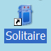

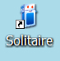



1. **Find** the Solitaire icon on your desktop.

**Click** on the icon to select it.

1. **Press** the *Enter* key to open the game (or **double click** on the icon).
2. A Solitaire window will open that does not fill the screen. **Click** on the maximise box in the top right hand corner to fill the whole screen with the window.

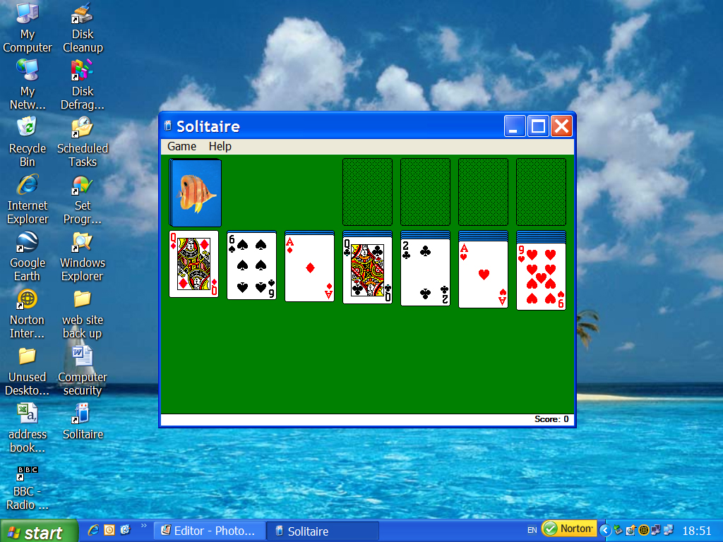

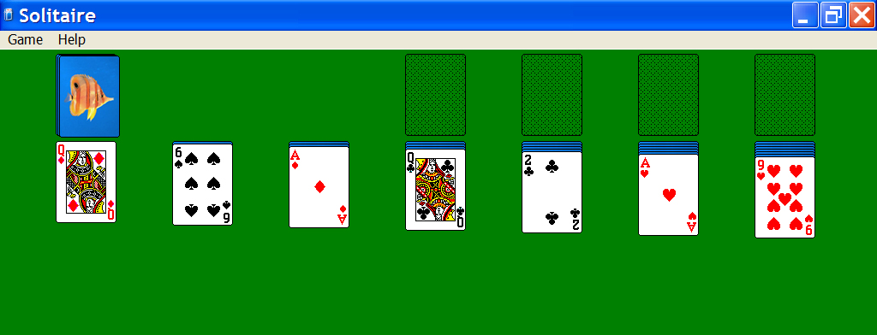



maximise minimise close boxes.bmp

1. **Choose** your own deck of cards! - **Click** on “Game” on the menu bar, **press** the *down arrow* key three times to **navigate** down to “Deck” (it will become selected in blue) and **press** *Enter* to open “Deck”. (Alternatively **click** on “Game” then **click** on “Deck”).

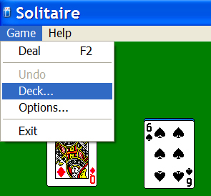

**Tip**

Using your *arrow* keys to navigate through different options is the same method used with mobile phones and remote controls…(and a lot of new technology interfaces). It is a very good way to slow down and learn more. It also avoids dependency on the mouse and the possibility of repetitive strain injury.



1. The “Select Card Back” box appears for you to **select** the deck of cards you like best. **Click** on that design (it will become outlined in blue) and **click** on “OK”.

**Tip**

The “Solitaire” window’s title bar is a faded blue showing that it is inactive.

The “Select Card Back” box has a bright blue title bar showing that it is active.

This means that the computer’s attention is currently on the “Select Card Back” box and you can use your arrow keys to navigate around this box.

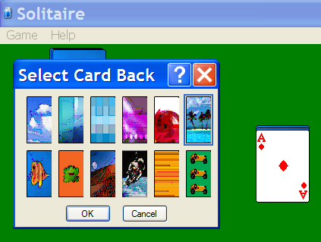



1. The game is now ready to be played with this deck…. this is the fun part. By playing Solitaire your attention is on the game and not on the difficulty of using the mouse which enables you to dramatically improve your mouse skills in a short space of time.

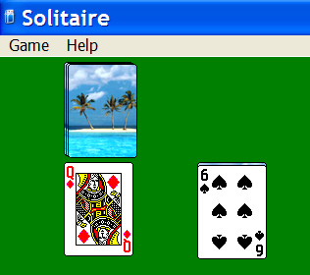

1. If you are not sure of the rules of how to play Solitaire you will need to get “Help”. **Click** on the “Help” menu, **press** the *down arrow* key once to **navigate** to “Contents” (it will be selected in blue) and **press** *Enter* to open the “Contents” of Help. (Alternatively **click** on “Help” then **click** on “Contents” - or **press** the F1 key for help).

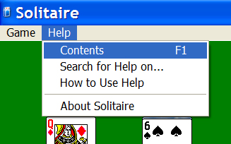



1. This is the Solitaire Help window. **Click** on the Index tab to see an index of chapters….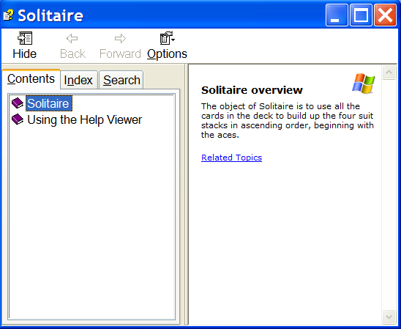

**Solitaire overview**

The object of Solitaire is to use all the cards in the deck to build up the four suit stacks in ascending order, beginning with the aces.



1. **Click** on the chapter title that interests you and **click** on the “Display” button. The details will open on the right hand side (or **double click** on the chapter title).

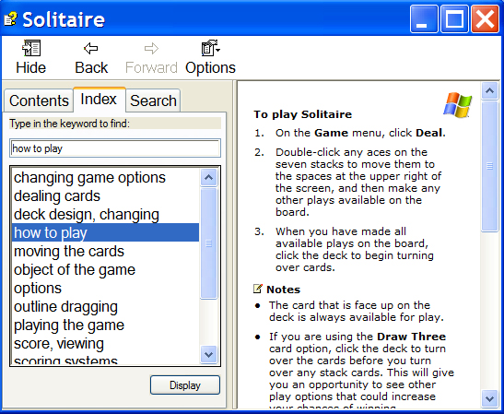



**Tip**

**maximise minimise close boxes.bmp**

You could maximise this window to read the text more easily.



1. The game of Solitaire is played by arranging cards in descending order (with alternate colours) on the seven row stacks (stacks of cards in a row of 7), so that you can reveal the cards hidden underneath, and go on to successfully build up the four same suit stacks above them in ascending order, beginning with the aces.

To turn over a new card, **click** on the deck. Good luck…..

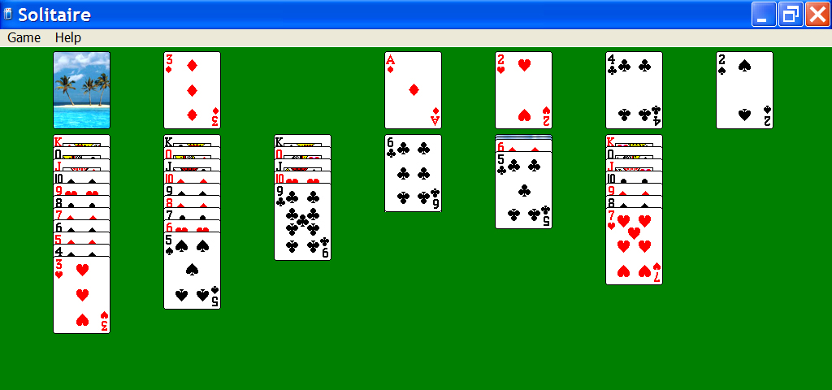



1. This is what happens when you successfully stack all the four suits from ace to king!

